CONFIDENTIAL CS/OCT 2026/MAT133

UNIVERSITI TEKNOLOGI MARA FINAL EXAMINATION

COURSE
COURSE CODE
EXAMINATION TIME
PRE CALCULUS
MAT133 OCTOBER 2026
2 HOURS

INSTRUCTIONS TO CANDIDATES

- This question paper consists of 5 questions.

- Answer ALL questions in the Answer Booklet. Start each answer on a new page.

- Do not bring any material into the examination room unless permission is given by the invigilator .
- Please check to make sure that this examination pack consists of: i) the Question Paper
  - a one - page Append ix 1
  - an Answer Booklet - provided by the Faculty
  - a graph paper - provided by the Faculty

- Answer ALL questions in English.

/

DO NOT TURN THIS PAGE UNTIL YOU ARE TOLD TO DO SO

This examination paper consists of 6 printed pages

QUESTION 1
a) Solve the rational inequality (-2x - 2)/(1 - 2x) <= -3. Express the answer in interval notation.
(5 marks)
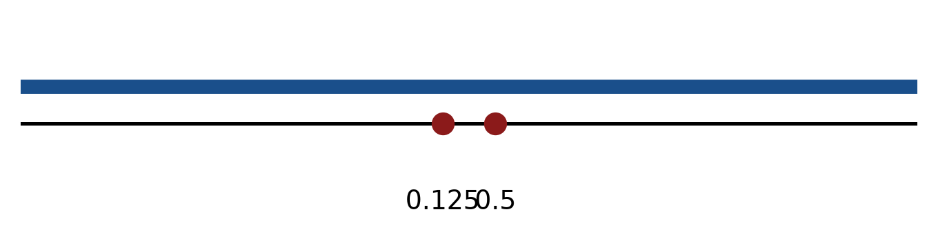
Figure: critical values.
b) Solve the inequality |3x + 5| > 6. Express the answer in interval notation and on a number line.
(5 marks)
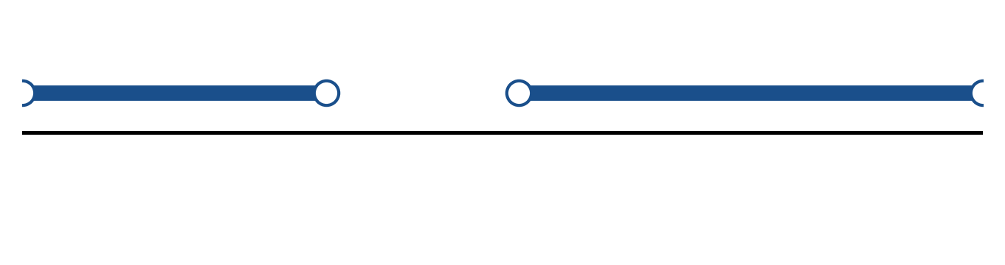
Figure: solution on a number line.
c) Sketch y = 3|x + 4| + 5. State the vertex, the y-intercept and any x-intercepts.
(5 marks)
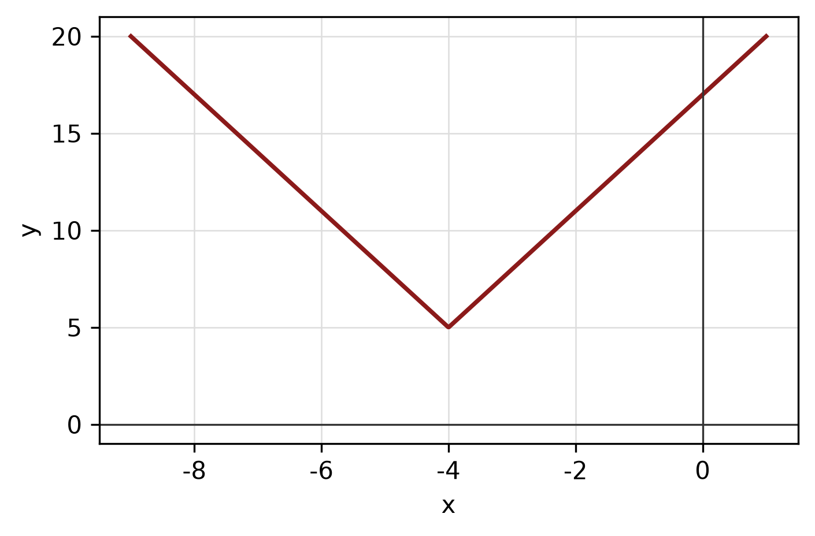
Figure: absolute-value graph.
QUESTION 2
a) Given f(x) = 5x + 4 and g(x) = 2x - 3, find (f + g)(x), (f - g)(x) and (f g)(x). State the domain of each.
(4 marks)
b) Given f(x) = (x + 6)/(4x - 1) and g(x) = √(2x - 4), state the domain of each function.
(4 marks)
c) Write x² + 10x + y² + 2y + 22 = 0 in standard form. Hence state the centre and radius and sketch the circle.
(5 marks)
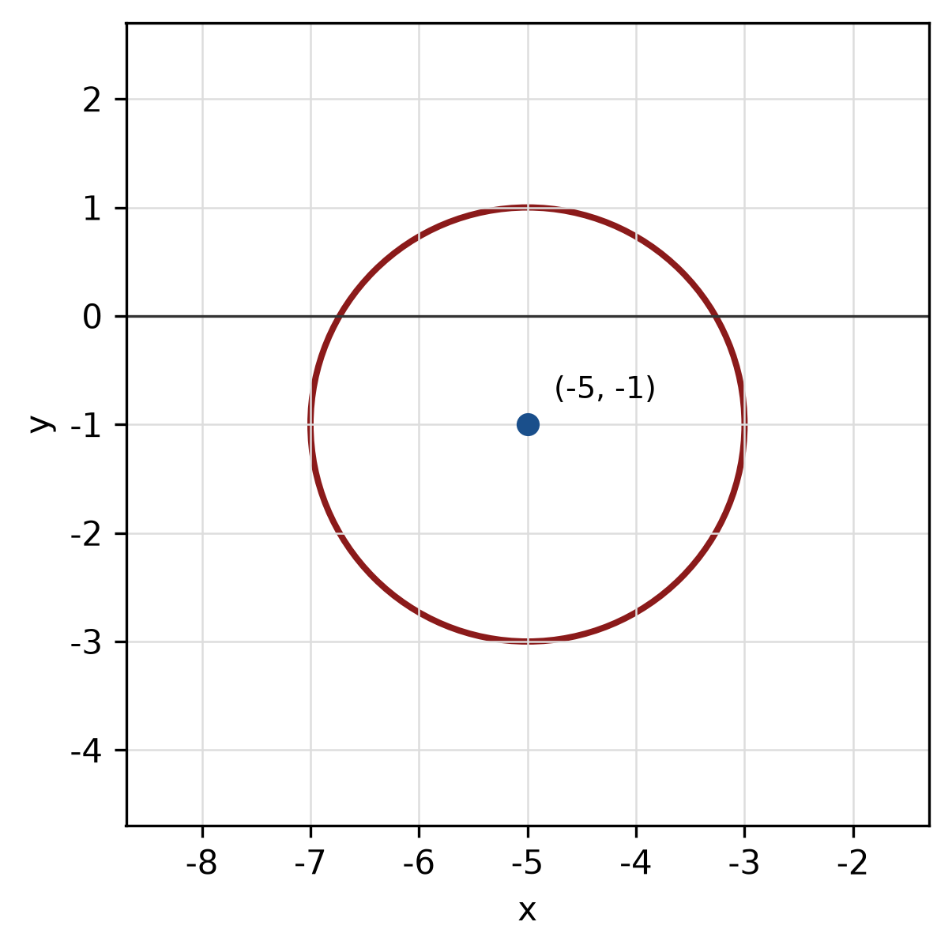
Figure: circle.
QUESTION 3
a) Given z₁ = -4 + i and z₂ = -2 + 6i, find z₁ × z₂ in the form a + bi.
(4 marks)
b) Evaluate i^19 and simplify completely.
(3 marks)
c) Use long division to find the quotient and remainder when f(x) = x^3 - 2x² + 6x - 4 is divided by x - 2.
(5 marks)
QUESTION 4
a) Solve the simultaneous equations
y = x² - 5
y = 4.
(5 marks)
b) Graph the system of inequalities below and shade the feasible region. State the vertices of the region.
x ≥ 0, y ≥ 0, 1x + 2y ≤ 8.
(5 marks)
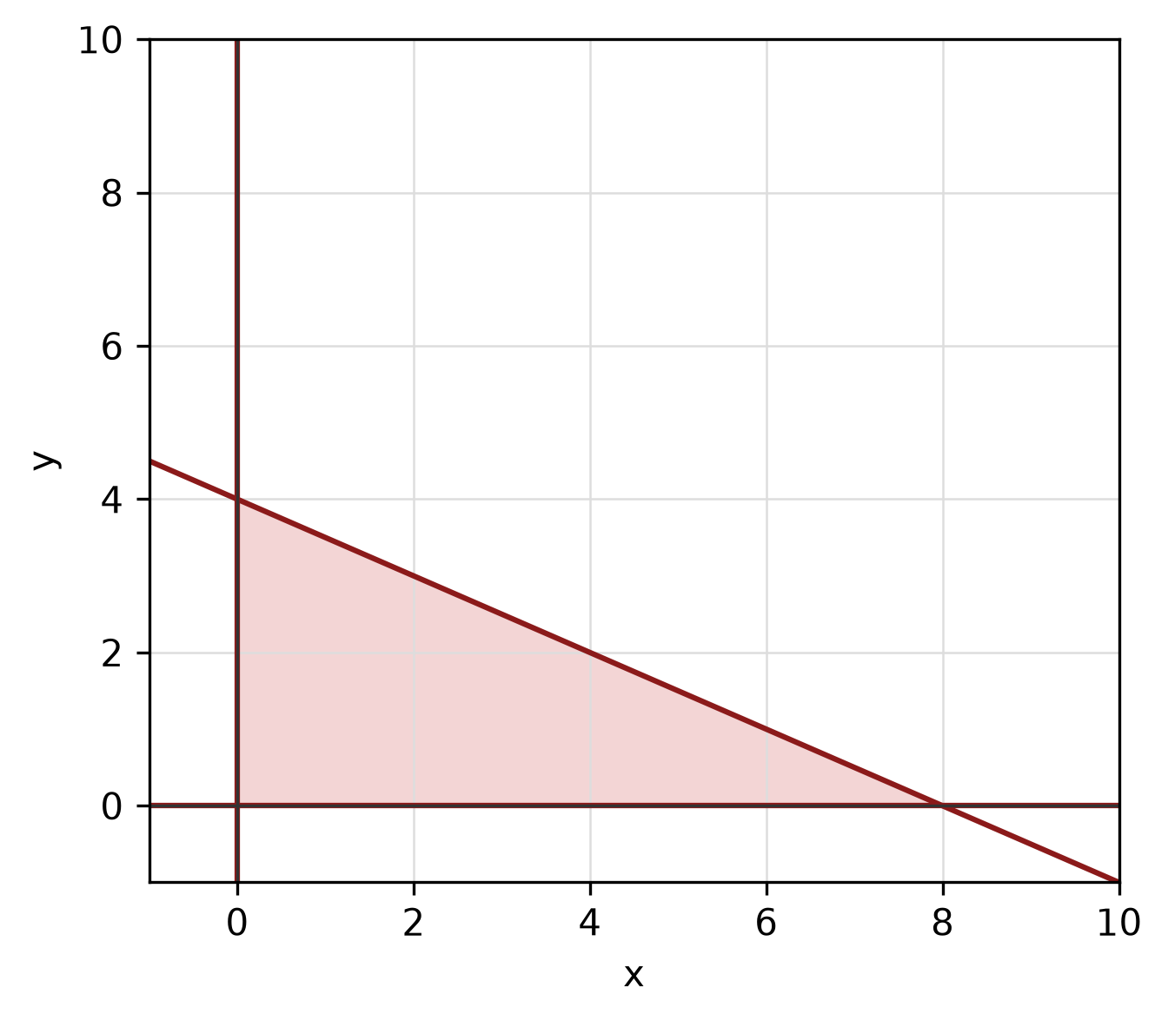
Figure: feasible region.
c) Find the equation of the line passing through (0, -3) and perpendicular to the line -4x + 4y - 5 = 0.
(5 marks)
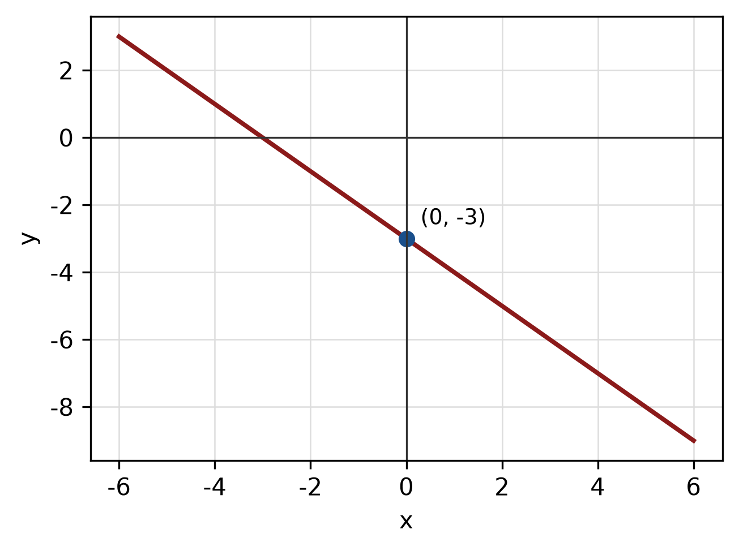
Figure: required line.
QUESTION 5
a) Solve the trigonometric equation cos² x - 3cos x/2 + 1/2 = 0 for 0° ≤ x < 360°.
(5 marks)
b) Convert 30° to radians, and convert π/6 radians to degrees.
(3 marks)
c) In triangle ABC, b = 6 cm, c = 10 cm and A = 60°. Use the cosine rule to find a.
(4 marks)
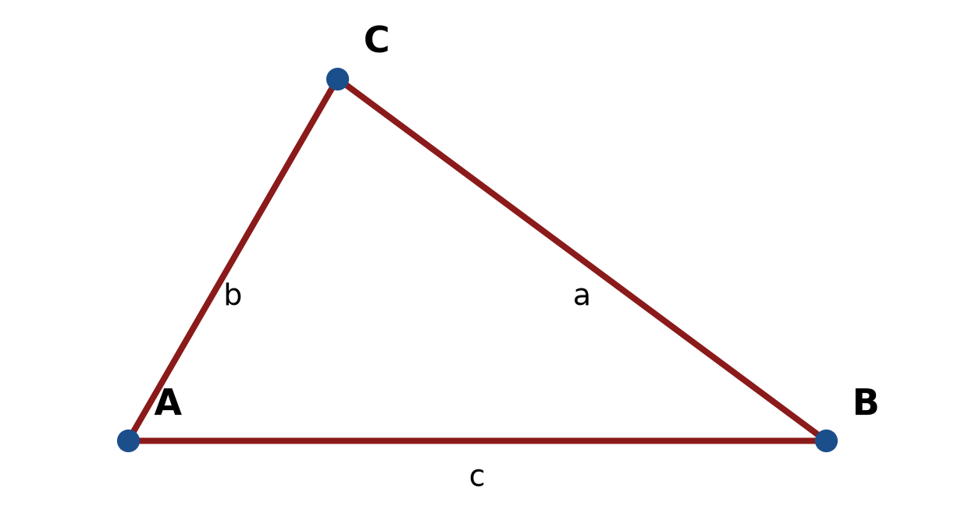
Figure: triangle ABC.
END OF QUESTION PAPER

APPENDIX 1
Formula sheet (as supplied with the paper).
sin² A + cos² A = 1 | tan² A + 1 = sec² A
sin(A + B) = sin A cos B + cos A sin B | tan 2A = 2 tan A / (1 − tan² A)
cos(A + B) = cos A cos B − sin A sin B | Arc length, s = rθ
tan(A − B) = (tan A − tan B) / (1 + tan A tan B) | Area of sector = ½r²θ
cos 2A = cos² A − sin² A | a / sin A = b / sin B = c / sin C
cos 2A = 1 − 2sin² A = 2cos² A − 1 | a² = b² + c² − 2bc cos A
sin 2A = 2 sin A cos A | Area of triangle = ½ab sin C

